Chapter 10, Solution 64.

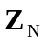 is obtained from the circuit in Fig. (a).
(a)
60 W
40 W
-j30 W
j80 W
Z_{N}

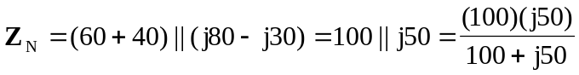
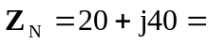 44.72Ð63.43° W

To find 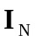, consider the circuit in Fig. (b).
(b)
60 W
40 W
-j30 W
j80 W
3Ð60° A
I_{s}
I₁
I₂
I_{N}

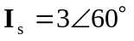

For mesh 1,
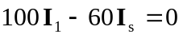
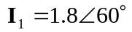

For mesh 2,
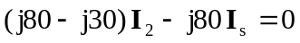
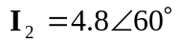

I_{N} = I₂ – I₁ = 3Ð60° A

